St Lawrence Eastern Lake Ontario Partnership Regional Invasive Species Management
2026 Call for Special Project Nominations
Project Overview
Project Title:
Brief summary of project
(Less than 50 words):

Start and Completion Dates:
Total amount requested:

Project Information
Project Contact Person:
Telephone Number:
Email:
Organization or Entity Applying:
Business Mailing Address:
City/ State/ Zip:
Is the applicant a non-profit organization? (Y/N):
Is the applicant a state registered minority/women-owned business? (Y/N):
If yes, please provide ID
Is the proposed work located on public or private property? If public, briefly describe.
iMapInvasives Username, Person #

The deadline for project nominations is January 6th, 2026, at 11:59PM. Please complete in full as a PDF document using the template provided and submit by uploading to Google forms, more information can be found on our website. Please review supporting documents on our web page before proceeding with the proposal. If you have any questions, please email Brittney Rogers, brittney.rogers@TNC.ORG, Invasive Species Program Director, SLELO PRISM. Projects will be reviewed and selected by the PRISM team. Notice of contract awards will be announced by January 16th, 2026. Formal agreements will be subject to approval by TNC and the NYSDEC Invasive Species Coordination Section and may take up to 8 weeks to finalize.
Project budgets are not to exceed $24,500 and should be no less than $10,000. Projects do not require any matching funds. If selected, recipients and all subsequent subcontractors are subject to both TNC and NYSDEC contracting policies and requirements. Awards are also contingent upon specific insurance requirements. An initial project kickoff meeting with SLELO PRISM staff and project lead, mid-season report, newsletter or blog update, and a final report will be required. Recipients are also required to present their project at two PRISM Partner Meetings.
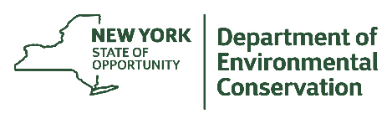
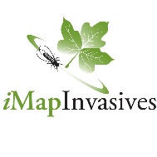

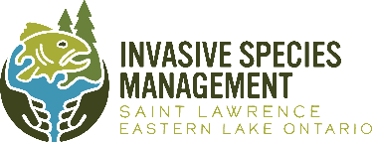
Funding for SLELO PRISM is provided through the New York State Environmental Protection Fund through NYS Department of Environmental Conservation through Contract C012859 with The Nature Conservancy
APPENDIX A. SCOPE OF WORK: NO MORE THAN 4 PAGES, CALIBRI 11PT FONT

APPENDIX B. BUDGET - NO MORE THAN 2 PAGES, CALIBRI 11PT FONT

Budget Category | Project Total | Requesting | Match
Personal Services:
Employee Salary and Wages
Fringe Benefits
Sub-Total
Non-Personal Services:
Equipment
Supplies and Materials
Travel
Communications
[Outreach materials]
Contract Services
[Outside/Subcontractor Service Fees]
Permitting
Other (explain below)
Indirect costs
Sub-Total
TOTAL:

Cost Proposal / Budget Narrative:

