2020 New York
Invasive Species Awareness Week
SOCIAL MEDIA TOOLKIT
New York Invasive Species Awareness Week (ISAW) is a statewide campaign being held the week of June 7-13, 2020 to educate and inform citizens of New York about the threat of invasive species and opportunities for action. This year’s theme is “2020 Vision: Focus on Invasive Species.” We encourage you to promote ISAW and your events on social media—it’s free and easy to use. Follow these helpful guidelines to make the most of your efforts on Facebook, Twitter, Instagram and other platforms:
- Know your audience—if you are trying to reach a certain group (anglers, gardeners, the general public), be sure to craft messages that speak to their interests and priorities.
- Keep your posts concise and provide accurate information that is easy to understand.
  - Twitter has a strict 280-character limit so be sure to hone your messaging!
- Link to additional resources where the user can read about a topic in more detail.
- Make your posts visually appealing—support information with photos when possible.
  - Need photos? Use this website for a variety of free to use high quality photos of invasive species: https://www.invasive.org/images.cfm.
- Tag your partners to enhance your reach.
- If possible and relevant, link to your organization's webpage to drive traffic to your site.
- Don't inundate your followers–limit your posts to no more than 2-3 times per day.
- Use the hashtag #NYISAW on all your ISAW related posts.
- Want to broadcast your events live? Check out these resources on Facebook, Instagram and Twitter to help guide you!
- After using your social media platforms, analyze the results! Look at the performance of your posts to see what worked and what didn’t. Successful posts will generate a lot of likes, comments and shares.
- Looking for ideas? "Sharing" posts from your partners makes life easier. You can start by sharing posts, images, and videos from the Department of Environmental Conservation's Facebook page: https://www.facebook.com/NYSDEC/.

Example posts:

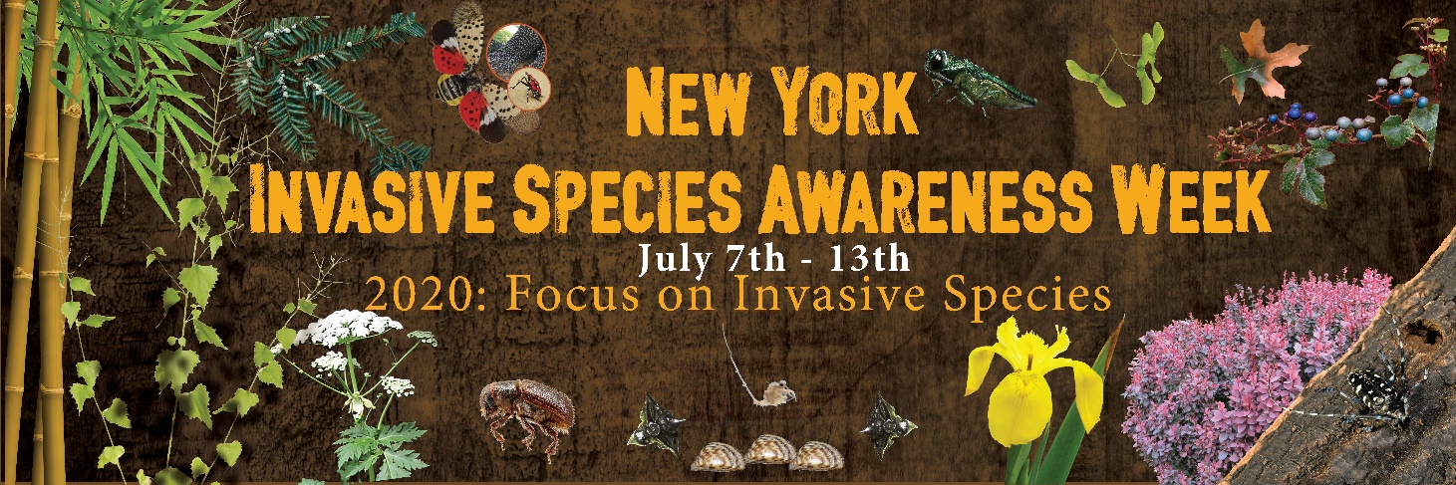
Facebook: Help stop the spread of invasive species! June 7th-13th marks the seventh annual Invasive Species Awareness Week (ISAW). The mission of ISAW is to promote knowledge and understanding of invasive species and the harm they can cause by engaging citizens in a wide range of activities across the state and empowering them to take action to help stop the spread. For information on events and what you can do to help, visit www.nyisaw.org #NYISAW

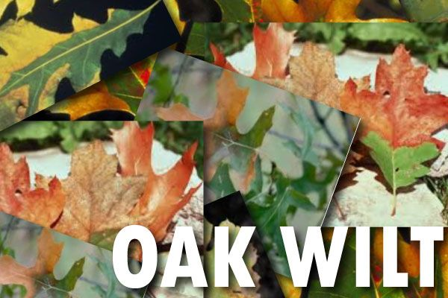
https://images.app.goo.gl/Na5BQF46sfuWfe6B7
- Help prevent the spread of oak wilt, a deadly oak disease, by avoiding pruning oaks in the summer! http://www.dec.ny.gov/lands/46919.html #NYISAW

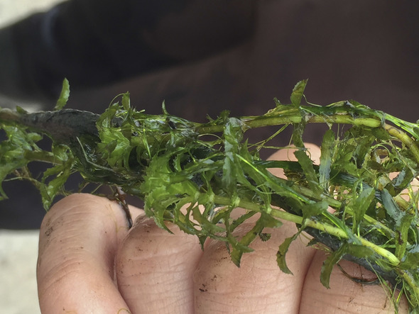
Hydrilla
https://images.app.goo.gl/hW3H3bazqT1oxZ8g9
- Hydrilla (Hydrilla verticillata) is the world’s most successful aquatic invasive plant. It rapidly spreads and causes severe impact to water quality, native plant and fish communities, recreation, irrigation, and water treatment facilities. Learn more at https://www.sleloinvasives.org/invasives/invasive-species-slelo-region/

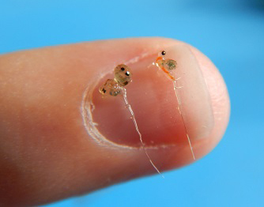
Spiny Waterflea

https://images.app.goo.gl/PpGCc67cEsVQZmYZA

- The spiny waterflea is a microscopic animal that has negative impacts on fish populations. #CleanDrainDry watercraft to prevent the spread!
Learn more at https://www.sleloinvasives.org/invasives/invasive-species-slelo-region/

